**Human resources management Plan**

**D7 Auto Service Center Web-App**

**D7 Auto Service Center**

**C.M. DELOS REYES AVENUE**

**GENERAL TRIAS, CAVITE, 4107**

Table of Contents

1. Staffing Management Plan 3

1.1. Introduction 3

1.2. Roles and Responsibilities 3

1.3. Project Organizational Charts 3

1.4. Staffing Management 3

# List of Tables

Table 1 Roles and Responsibilities 4

Table 2 Staffing Management Table 7

# List of Figures

[Figure 1 Project Organizational Chart 7](https://asiapacificcollege.sharepoint.com/sites/PROJMANT3MI201MI203/Shared%20Documents/Group%2001%20Elite%20Four/Week%207%20-%2010/ELITE%20FOUR%20-%20Human%20Resource%20Management%20Plan.docx#_Toc134895195)

## **Staffing Management Plan**

## **Introduction**

A human resource management constructed and composed under great effort, is a key towards success of a project, ensuring that these projects are well managed and filled with positions necessary to complete the deliverables from the beginning to its turnover. Roles, and its duties must be clearly defined, as well as the performances being tracked for the management measures, are also essential for the project’s strategizing for efficiency and effectiveness.

This plan is utilized to effectively manage the project’s team; by means of providing an in-depth definition of the roles and responsibilities of each team members, while keeping communication a top priority to ensure productivity runs through at its optimum level for the project. With the clear understanding of the roles, its assigned power for authorization, responsibility, and competency, this plan will be of great use in understanding what are the key responsibilities of each member of the project team.

## **Roles and Responsibilities**

One of the crucial parts of the Human Resources management plan is outlining the roles and responsibilities of all project team members and stakeholders for the matter. This ensures that all team members are well informed of their individual parts to play in the succession of the project.

This planning will also define the level of authority and what decisions can be decided upon by members, and what are the extent of their authority. This is to make sure that the resources are maximized to their potential.

The human resource management aims to be a roadmap for the project team members that will serve as guidance in understanding roles and responsibilities for the project’s success in execution and delivery of tasks assigned accordingly and effectively.

Table 1 Roles and Responsibilities

|  |  |  |  |
| --- | --- | --- | --- |
| Role | Authority | Responsibility | Competency |
| Project Sponsor | Ultimate decision-making authority for the project | Provides project funding and resources. Defines project scope, goals, and objectives. Reviews and approves project deliverables and changes. Acts as a liaison between the project team and the organization's executive management. | Strong leadership, strategic thinking, and communication |
| Project Manager | Responsible for project execution and delivery | Develops and manages the project plan. Defines project roles, responsibilities, and timelines. Identifies and manages project risks and issues. Facilitates communication between project stakeholders. Ensures project meets quality, budget, and schedule requirements. Reports project status and progress to project sponsor and executive management. | Strong project management, leadership, and communication |
| IT Team (Internal Users) | Provides technical expertise and support for project | Provides technical input into project planning and execution. Develops, tests, and implements technical solutions. Identifies and resolves technical issues. Collaborates with other project teams to ensure technical requirements are met. | Strong technical knowledge, problem-solving, and collaboration |
| Documentation Team (Internal Users) | Responsible for documentation of project | Develops and maintains project documentation, including requirements, design, testing, and user manuals. Ensures that project documentation is complete, accurate, and up to date. Provides guidance and support to project team members on documentation standards and requirements. | Strong writing, editing, and organizational skills |
| Customers (External Users) | The users who will use the end product or service of the project | Provides feedback on project deliverables. Collaborates with the project team to identify and refine requirements. Tests and evaluates the project deliverables to ensure that they meet their needs. Communicates their needs and expectations to the project team. | Strong domain knowledge and communication skills |
| Client (External Users) | The entity or organization that has initiated the project and will receive the project deliverables | Provides input and feedback on project deliverables and progress. Reviews and approves project deliverables and changes. Provides project funding and resources. Communicates their needs and expectations to the project team. | Strong leadership, communication, and negotiation skills |

## **Project Organizational Charts**

A project organizational chart visualizes the project's structure, roles, and responsibilities, clarifying reporting lines, decision-making authority, and communication channels within the team and with external stakeholders. The chart aligns each team's critical role with the project goals and objectives, minimizing confusion and ambiguity, facilitating effective communication, decision-making, and collaboration, all essential for project success.

[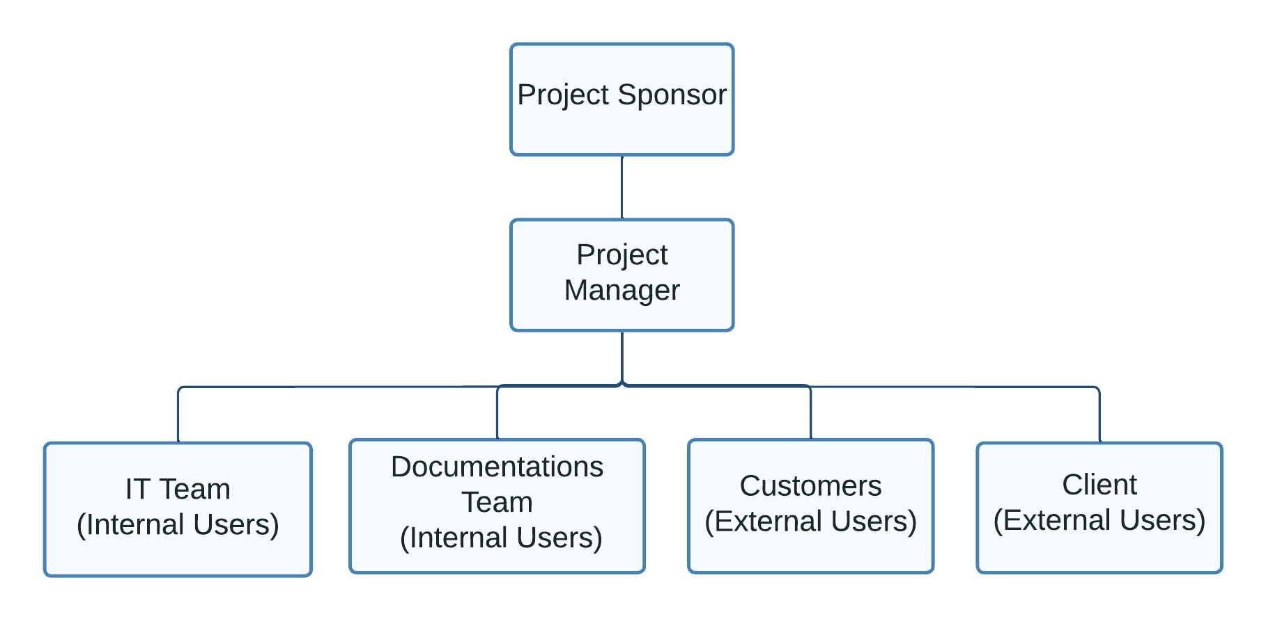](https://lucid.app/lucidchart/fe853756-3432-44bc-a3f4-1df8c2759ecb/edit?crop=content&page=0&signature=2a514709e82d4fec71321374d7f1ab4b3525530c6346eeb40c77e2710307624e)

Figure 1 Project Organizational Chart

## **Staffing Management**

Throughout the project’s duration, Staffing Management is of utmost importance because it defines the most essentials for the team and their roles to have a successful project execution. Being able to outline the strategies, and the processes of each project phase from planning to deployment, to effectively manage acquiring to turnover, makes human resources clearly informed of their tasks and responsibilities.

* + - Acquisition is a must to be done in the timeliest way to acquire the necessary skills and expertise needed in the project. This will be comprised of requiring new hires, contractors, and even the utilization of the internal staff as needed for the project’s completion.
    - Training before anything else will also be observed to lessen the errors in the project working environment, as well as further honing of skills to have better utilization of it in the creation and execution of deliverables accordingly.
    - Performance Quality Evaluations and Assessments are also to be done to determine which fields require much work, and improvement, to maximize efficiency within the premises of the working environment in a healthy, and effective way.
    - A rewards and recognition system will also be implemented within the project’s duration because it will promote better work quality and appreciation of the members’ work contribution to and for the project.

The project’s Human Resource and Staffing may be subjected to change as there are going to be contingencies and updates within the project as time moves forward, which is why it is expected to have updates in the staffing management to fulfill the roles and responsibilities needed to complete the project.

Table 2 Staffing Management Table

|  |  |  |  |  |  |
| --- | --- | --- | --- | --- | --- |
| Role | Project Responsibility | Skills Required | Number of Staff | Performance Reviews | Recognition and Rewards |
| Project Sponsor | Provides funding and resources for the project. | Strategic planning and leadership skills | 1 | Quarterly or as needed. | Bonus or promotion |
| Project Manager | Oversees the day-to-day operations of the project | Project management, communication, leadership skills | 1 | Monthly or as needed. | Bonus or promotion |
| Project Team Leader | Leads a team of project members. | Leadership, communication, delegation | 1 | Monthly review | Performance-based bonuses or salary increases. |
| Project Members | Contributes to the project's execution and completion. | Technical or functional skills as required by the project. | Varies depending on project requirements. | Weekly review or as needed. | Performance-based bonuses or salary increases. |